Steven Rizo

Module 7

#4:

Figure 1: Table of data for varying terrain corrections for the Medicine Lake area. Standard angular frequency is 10 degrees for both 90m and 30m DEM with a distance interval of 200m. The low angle and short distance values are obtained using one half of their respective standard, and the high angle and long distance values are obtained using double their respective standard.

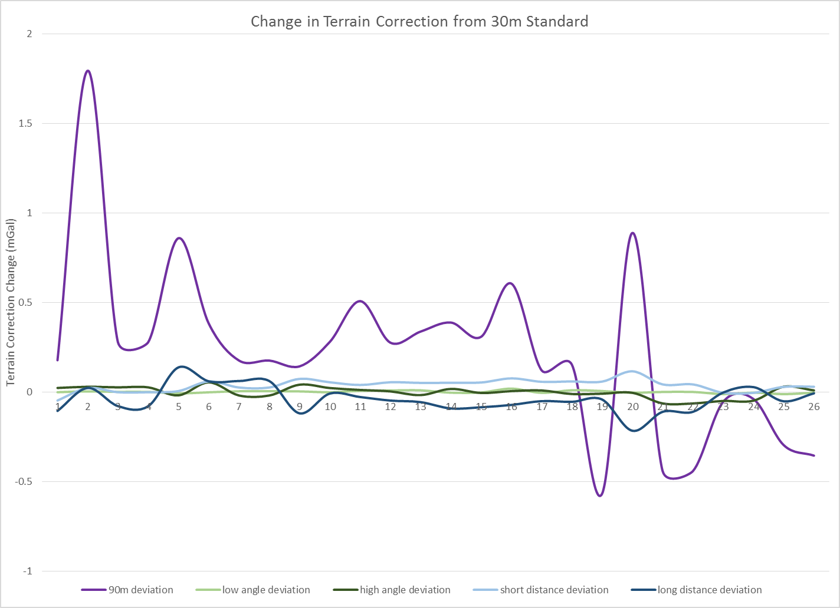Figure 2: A graph of change in terrain correction obtained by subtracting the 30m standard value from each of the other terrain corrections.

The terrain corrections calculated with the 90m DEM give higher values than most of the 30m DEM corrections. The differences are also an order of magnitude larger than the deviations within the 30m DEM for varying angles and distances.

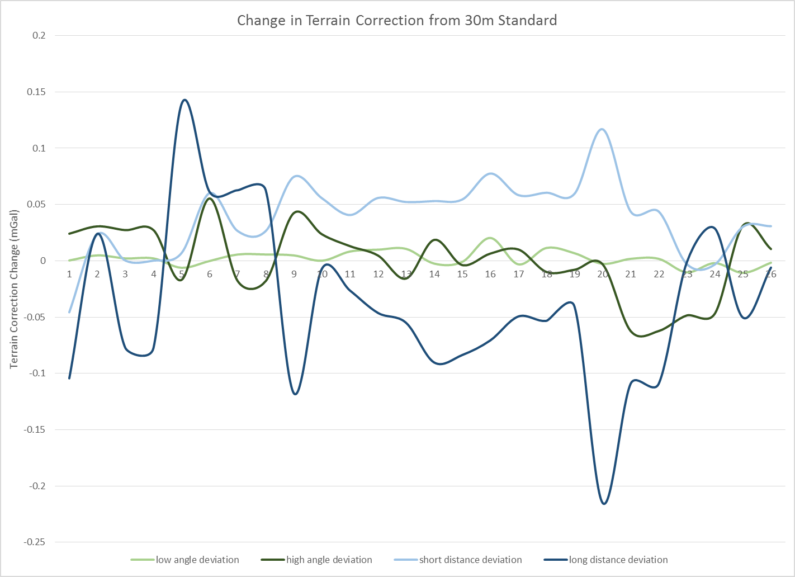Figure 3: A graph of change in terrain correction obtained by subtracting the 30m standard value from each of the other terrain corrections. The 90m DEM terrain correction deviation is removed to better show the smaller deviations between varying 30m DEM corrections.

For both angle and distance changes, halving the standard values seem to raise the terrain correction while doubling them lowers the terrain correction value more than the halved standards. The doubled values also show a larger variation with higher highs and lower lows in both cases, although this could be a result of the larger value change associated with doubling compared to halving the standards. While some of the time doubling the value increases the effect that halving the standard does, most of the terrain corrections move in opposite directions when comparing larger and smaller angles or distances. This is the most obvious for samples 9-26 where the light (lower value) and dark (higher value) lines all move in generally the opposite direction away from the standard values. Changing the angular frequency seems to create a more varied change in terrain correction with values going over and under the standard for both the higher and lower angle cases. Changing the radial distance seems to have a stronger difference between higher and lower distances. While both of these still have values above and below the standard, the short distance deviation is predominantly higher than the standard while the long distance deviation is generally lower.